# SOP - Pl_Clicks_Drop_plmt

1. Check Sherlock and Control Center if they are matching in timestamps.

Check placement Id in [Sherlock](https://console.sherlock.io/explore?left=%5B%22now-2d%22,%22now%22,%22Sherlock-PromQL%22,%7B%22expr%22:%22(sum(increase(TotalPLRecord_total%7B_namespace_%3D%5C%22promotedlisting%5C%22,eventType%3D%5C%22PLC%5C%22,placement%3D%5C%22100665%5C%22,pool%3D%5C%22r1organicrealtimeingest0%5C%22%7D%5B1h%5D))%20%2F%20sum(increase(TotalPLRecord_total%7B_namespace_%3D%5C%22promotedlisting%5C%22,eventType%3D%5C%22PLC%5C%22,placement%3D%5C%22100665%5C%22,pool%3D%5C%22r1organicrealtimeingest0%5C%22%7D%5B1h%5D%20offset%201w)))%20%22,%22refId%22:%22A%22,%22exemplar%22:false%7D%5D&forceLogin&orgId=1)

<https://console.sherlock.io/explore?left=%5B%22now-2d%22,%22now%22,%22Sherlock-PromQL%22,%7B%22expr%22:%22(sum(increase(TotalPLRecord_total%7B_namespace_%3D%5C%22promotedlisting%5C%22,eventType%3D%5C%22PLC%5C%22,placement%3D%5C%22100665%5C%22,pool%3D%5C%22r1organicrealtimeingest0%5C%22%7D%5B1h%5D))%20%2F%20sum(increase(TotalPLRecord_total%7B_namespace_%3D%5C%22promotedlisting%5C%22,eventType%3D%5C%22PLC%5C%22,placement%3D%5C%22100665%5C%22,pool%3D%5C%22r1organicrealtimeingest0%5C%22%7D%5B1h%5D%20offset%201w)))%20%22,%22refId%22:%22A%22,%22exemplar%22:false%7D%5D&forceLogin&orgId=1>

Check now vs 1 week vs 2 weeks

<https://console.sherlock.io/explore?left=%5B%22now-6h%22,%22now%22,%22Sherlock-PromQL%22,%7B%22expr%22:%22(sum(increase(TotalPLRecord_total%7B_namespace_%3D%5C%22promotedlisting%5C%22,eventType%3D%5C%22PLC%5C%22,placement%3D%5C%22100665%5C%22,pool%3D%5C%22r1organicrealtimeingest0%5C%22%7D%5B1h%5D))%20%2F%20sum(increase(TotalPLRecord_total%7B_namespace_%3D%5C%22promotedlisting%5C%22,eventType%3D%5C%22PLC%5C%22,placement%3D%5C%22100665%5C%22,pool%3D%5C%22r1organicrealtimeingest0%5C%22%7D%5B1h%5D%20offset%201w)))%20%3C%200.6%22,%22refId%22:%22A%22,%22exemplar%22:false%7D%5D&forceLogin&orgId=1&right=%5B%22now-6h%22,%22now%22,%22Sherlock-PromQL%22,%7B%22expr%22:%22sum(increase(TotalPLRecord_total%7B_namespace_%3D%5C%22promotedlisting%5C%22,eventType%3D%5C%22PLC%5C%22,placement%3D%5C%22100665%5C%22,pool%3D%5C%22r1organicrealtimeingest0%5C%22%7D%5B1h%5D))%20%22,%22refId%22:%22A%22,%22exemplar%22:false%7D,%7B%22refId%22:%22B%22,%22exemplar%22:false,%22instant%22:true,%22range%22:true,%22expr%22:%22sum(increase(TotalPLRecord_total%7B_namespace_%3D%5C%22promotedlisting%5C%22,eventType%3D%5C%22PLC%5C%22,placement%3D%5C%22100665%5C%22,pool%3D%5C%22r1organicrealtimeingest0%5C%22%7D%5B1h%5D%20offset%201w))%22%7D,%7B%22refId%22:%22C%22,%22exemplar%22:false,%22instant%22:true,%22range%22:true,%22expr%22:%22sum(increase(TotalPLRecord_total%7B_namespace_%3D%5C%22promotedlisting%5C%22,eventType%3D%5C%22PLC%5C%22,placement%3D%5C%22100665%5C%22,pool%3D%5C%22r1organicrealtimeingest0%5C%22%7D%5B1h%5D%20offset%202w))%22%7D%5D>

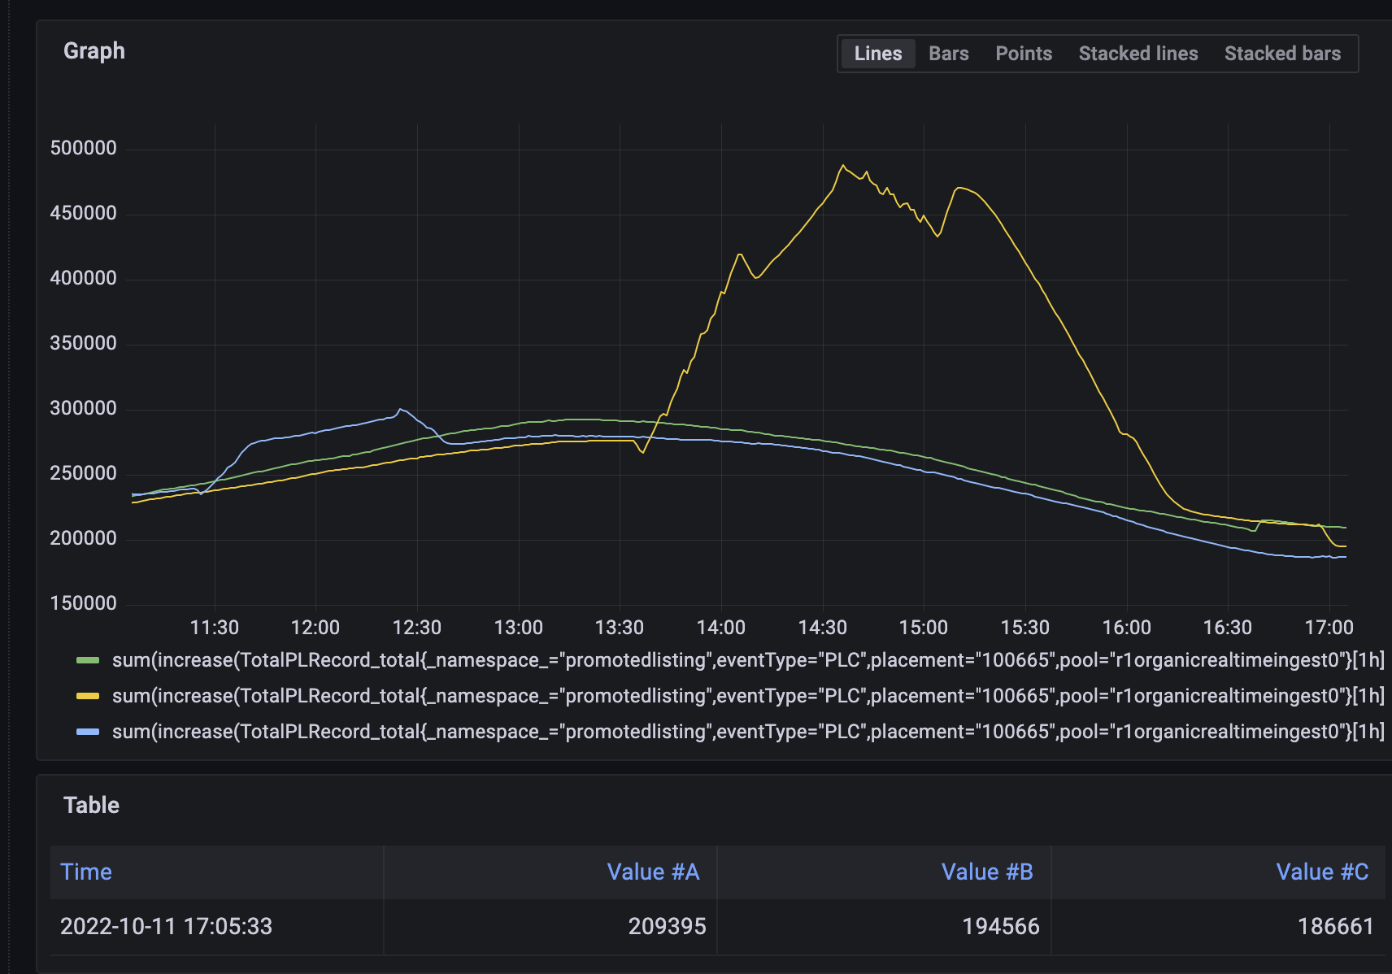

If Rheos outage, check Topics Throughput of Rheos in Sherlock.

<http://rhs-monitoring.vip.ebay.com/d/ceq8Wpvik/topics-throughput?orgId=1&var-streamName=behavior.pulsar&var-dc=rno&var-topic=behavior.pulsar.customized.2388028&var-clusterType=aggregation&from=now-24h&to=now>

